Performance Testing Phase

Objective of Testing:

  - Ensure the system accurately records and updates expenses.
  - Verify that reports and dashboards reflect correct totals and details.
  - Confirm that business rules and relationships between tables work correctly.
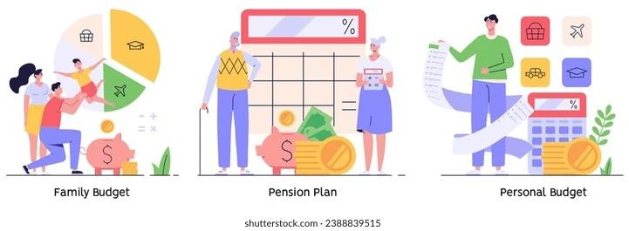

Testing Scope:

  - Daily Expenses entry and Family Expenses summary update.
  - Form validation for mandatory fields and correct data types.
  - Business rules execution for automatic calculations.
  - Report generation and dashboard accuracy.

Testing Methodology:

  - Manual Testing: Enter sample expense data and check updates in Family Expenses.
  - Validation Testing: Ensure mandatory fields cannot be left empty.
  - Integration Testing: Confirm that Daily Expenses correctly link and update Family Expenses.
  - Report Testing: Verify generated reports match the entered data.

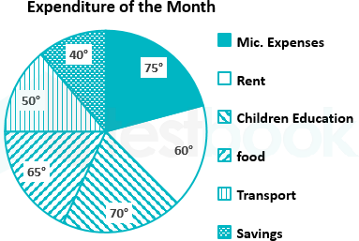

Expected Results:

  - Accurate daily and summary expense records.
  - Real-time update of total amounts when new entries are added.
  - Proper functioning of forms, validations, and business rules.
  - Correct display of reports and dashboards.

Tools Required:

  - ServiceNow Developer Instance for testing.
  - Sample data for entering expenses and verifying results.

Constraints:

  - Limited to testing within the ServiceNow Developer Instance.
  - Performance testing for very large datasets may not reflect real-time behavior in free instances.

- Project Progress:

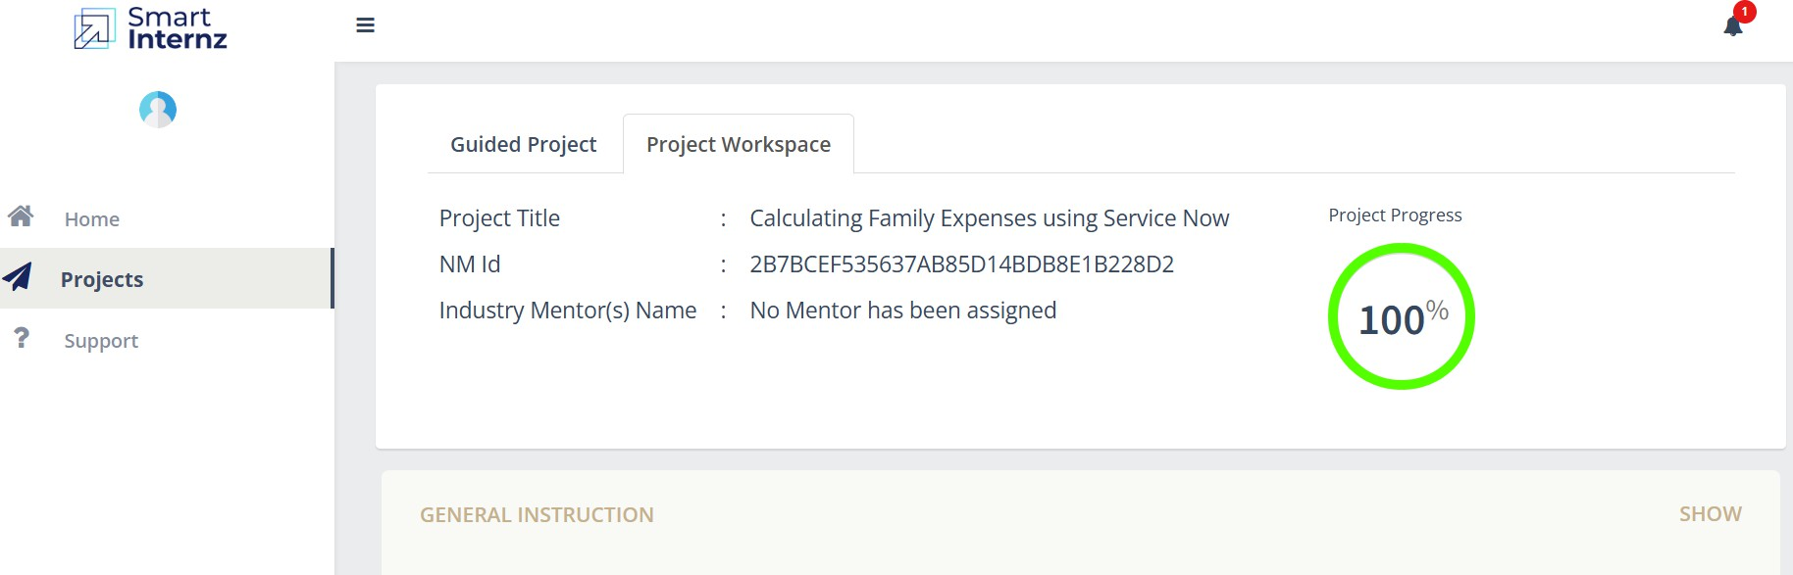
(Screen Shot)

